Figures displaying reproduced GAGE-B results (B)

Figure S-B 1 Bar chart showing the number of contigs on reproduced assemblies 2

Figure S-B 2 Bar chart showing the number of scaffolds on reproduced assemblies 3

Figure S-B 3 Scatterplot of genome fraction and the number of genes in contigs and scaffolds from reproduced assemblies 4

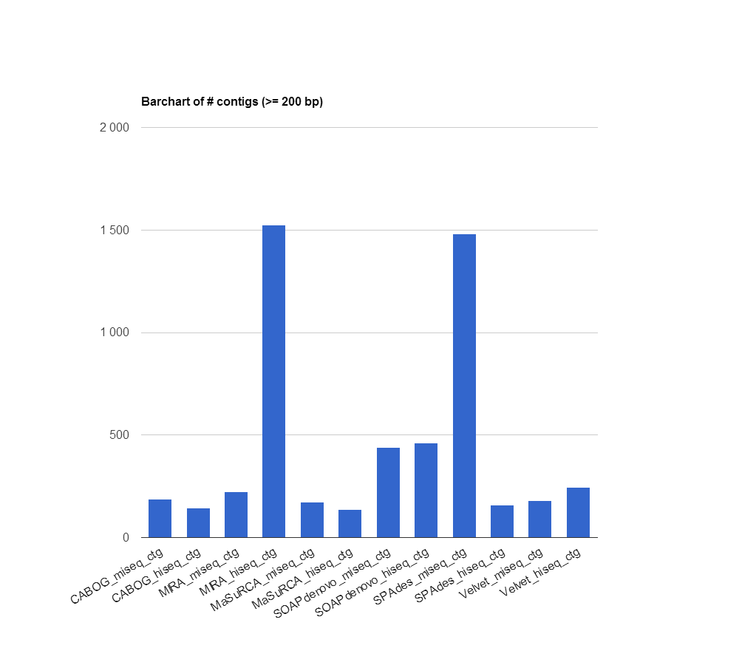

Figure S-B 1 Bar chart showing the number of contigs on reproduced assemblies

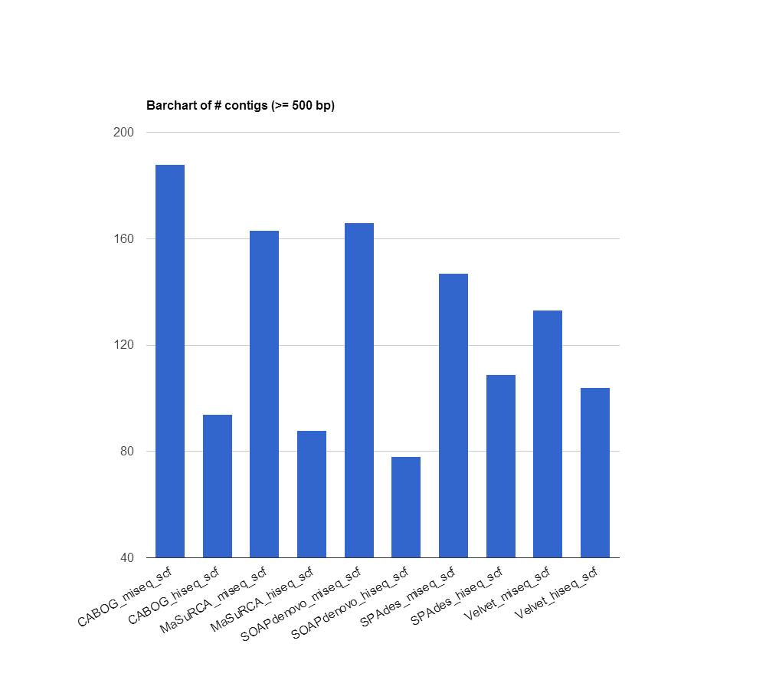

Figure S-B 2 Bar chart showing the number of scaffolds on reproduced assemblies

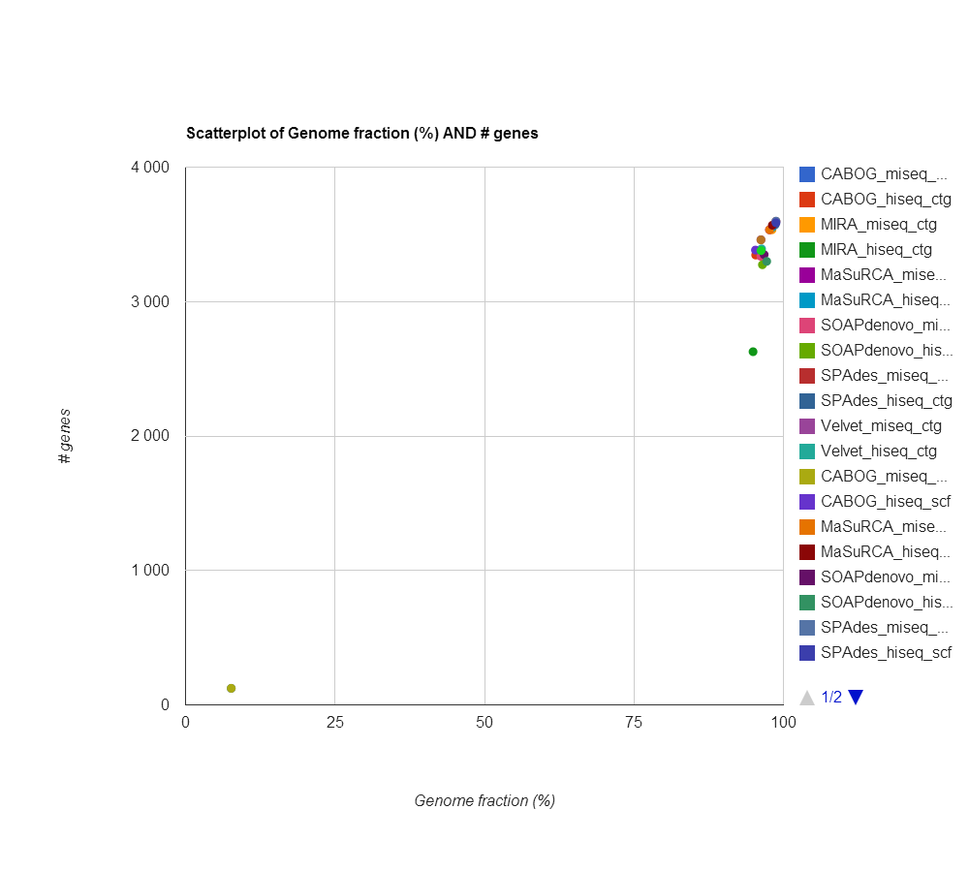

Figure S-B 3 Scatterplot of genome fraction and the number of genes in contigs and scaffolds from reproduced assemblies